**Important information!**

**Before using the device, please read the included user manual carefully.**

**CAMSPOT 3.1 WI-FI CONFIGURATION IN SEARCHTOOL APP**

**DOWNLOADING THE APP**

1. Download the camera app from  [www.overmax.eu.](quot;http://www.overmax.eu/&quot) and choose your camera model from “Products” menu. Open the sub-page of the product. Click the [HELP] tab and then - the gray arrow symbol to start downloading the file.



1. The downloaded file is compressed. Unzip the file using e.g. WinRAR.

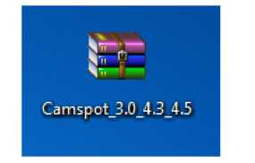

1. After unzipping the file you get the folder with the app.
2. Install the required app on your computer.

Wi-Fi camera configuration via SEARCH TOOL app and FIREFOX browser.

1. Use the included power adapter to connect the camera to a power outlet.
2. Connect the camera to an Internet router using the LAN cable. The camera must be connected directly to the router - not to your computer. The computer must be connected to the same network as the camera.
3. Start SearchTool.
4. Select your camera from the list of available devices. If the camera hasn’t been detected automatically, click “Refresh”.
5. Open the browser and select “videostream mode” (for FireFox).
6. Open the following tabs: NETWORK CONFIGURATION > WIRELESS LAN SETTINGS.

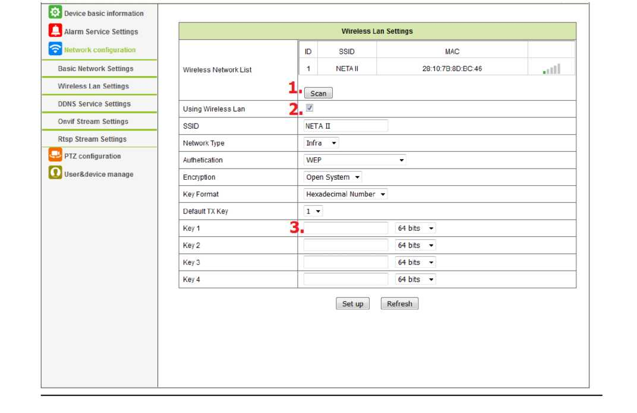

**Then follow the steps below:**

(Picture - point 1.) - Click the “Scan” button. Once the search is finished, click the network you want the camera to be connected with.

(Picture - point 2.) Tick the „Using Wireless Lan" option.

(Picture - point 3.) Enter the Wi-Fi password into the “Key l” field.

**Click the “SET UP”** button to confirm the operation.

The camera will restart automatically. Meanwhile you can disconnect the LAN cable from the camera. Once the camera is on again it operates via Wi-Fi.

**Important information!**

**Before using the device, please read the included user manual carefully.**

**THE PAPER VERSION OF THE USER MANUAL IS INCLUDED IN THE PRODUCT BOX. THE ELECTRONIC FORM CAN BE DOWNLOADED FROM** [WWW.OVERMAX.EU.](quot;http://www.overmax.eu/&quot)